

INSTALLATION AND OPERATION MANUAL

Mixer Amplifiers with Mp3/FM/BT
FA-3EB/FA-60EB/FA-120EB

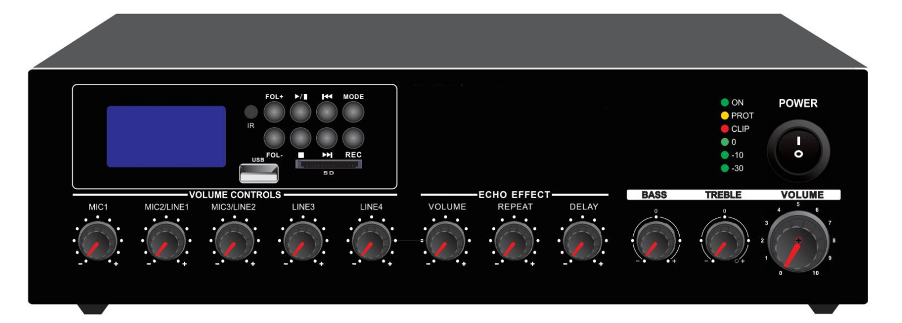




Caution: Please read this manual carefully before operating
Damage caused by misuse is not covered by the warranty

SAFTY WARNINGS!
- Read and keep these instructions.
- Heed all warnings and follow all instructions.
- Do not use this apparatus near water.
- Do not block any ventilation openings. Install in accordance with the manufacturer’s instructions.
- Do not install near any heat sources such as radiators, heat registers, stoves, or other apparatus that produce heat.
- Do not defeat the safety purpose of the polarized or grounding-type plug. A polarized plug has two blades with one wider than the other. A grounding type plug has two blades and a third grounding prong. The wide blade or the third prong is provided for your safety. If the provided plug does not fit into your outlet, consult an electrician for replacement of the obsolete outlet.
- Protect the power cord from being walked on or pinched particularly at plugs, convenience receptacles, and the point where they exit from the apparatus.
- Only use attachments/accessories specified by the manufacturer.
- Use only with the cart, stand, tripod, bracket, or table specified by the manufacturer, or sold with the apparatus. When a cart is used, use caution when moving the cart/apparatus combination to avoid injury from tip-over.
- Unplug this apparatus during lightning storms or when unused for long periods of time.
- Refer all servicing to qualified service personnel. Servicing is required when the apparatus has been damaged in any way, such as power-supply cord or plug is damaged, liquid has been spilled or objects have fallen into the apparatus, the apparatus has been exposed to rain or moisture, does not operate normally, or has been dropped.
- This appliance shall not be exposed to dripping or splashing water and that no object filled with liquid such as vases shall be placed on the apparatus.
- Plug this apparatus to the proper wall outlet and make the plug to be disconnected readily operable.
- Main plug is used as disconnected device and it should remain readily operable during intended use. In order to disconnect the apparatus from the mains completely, the mains plug should be disconnected from the mains socket outlet completely.
- WARNING: To reduce the risk of fire or electric shock, do not expose this apparatus to rain or moisture.
- An appliance with a protective earth terminal should be connected to a mains outlet with a protective earth connection.
WARNING!

TO PREVENT FIRE OR SHOCK HAZARD, DO NOT USE THE PLUG WITH
AN EXTENSION CORD, RECEPTACLE OR OTHER OUTLET UNLESS THE BLADES
CAN BE FULLY INSERTED TO PREVENT BLADE EXPOSURE.
TO REDUCE THE RISK OF FIRE OR ELECTRIC SHOCK, DO NOT EXPOSE
THIS APPLIANCE TO RAIN OR MOISTURE.
TO PREVENT ELECTRICAL SHOC
K, MATCH WIDE BLADE PLUG TO WIDE SLOT, FULLY INSERT.

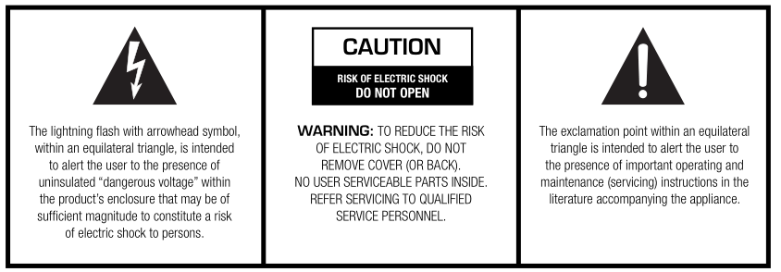

INTRODUCTIONS

Description
The PA Mixer Amplifier with MP3, FM tuner & blue tooth, its rated power output from 30W, 60W to 120W, it is ideal for school, super market, bank, hotel BGM and speech use. It is all in one solution with two sources, pre amplifier and mixer power amplifier into one unit, which is economy but of high reliable performance.

It integrates 2 audio sources into a mixer amplifier, plus Mic1(XLR) and Mic/Line input 2-3 (6.3mm Jack), two line inputs, one Tel input and one line output. Mic1 VOX with highest priority except Tel input. One USB and one SD slots on front provide easy access and operation for installer and end-user.

The amplifier is designed with complete protection of overload, short circuit and high temp to avoid any damage.
These amplifiers are suitable for applications in bank, mosque, school, hotel, restaurant, theme centers and shopping center.

Features
- Compact mini size public address amplifier
- Ideal for classroom sound system use
- Built-in 100V/70V transformer technology
- Tabletop amplifier with Mp3 player, FM , blue tooth
- Rate power output at 30W, 60W to 120W.
- Speaker output of 100V or 70V & 4Ohms-8 Ohms-16 Ohms
- Mp3 player with USB/SD input on front panel, IR remote control for Mp3 player, FM radio and blue tooth
- LED indicators for power, clip, protect and signal
- Mic1-3 and line 1-2. Mic1 of balanced XLR input with phantom power on rear panel. Mic2-3 microphone or line switchable unbalanced 6.3mm phone jack input. Line 1-2 input of RCA input and one RCA line output. Volume control for Mic1-3, line1-2, Mp3/FM, bass/treble and master
- With short-circuit, clip, overload and high temp protection
- AC220V or 115V & 24V DC both operation system

FRONT PANEL
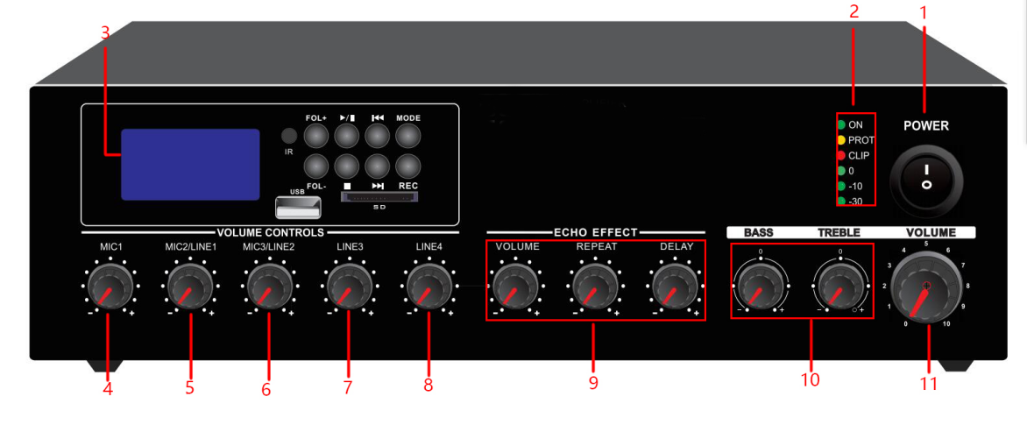

- Power indicator.
- Protection Indicator. Clip Indicator.
- Mp3/FM/Blue tooth media player module.
- Mic1 Attenuator.
- Mic/Line Input 2 Attenuator.
- Mic/Line Input 3 Attenuator.
- Line Input 3 Attenuator.
- Line Input 4 Attenuator.
- Echo function
- Bass and Treble
- Master Volume Control

REAR PANEL
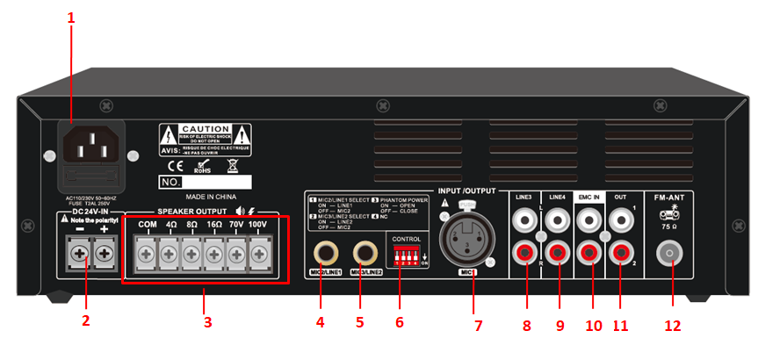

- AC Power Socket.
- 24V DC Battery Input.
- Speaker output COM,100V/70V,4-16OHMS.
- Mic2/Line1 input
- MIC3/Line4 input
- Dipswitch for MIC/LINE selector, phantom power and microphone priority
- Mic1 input
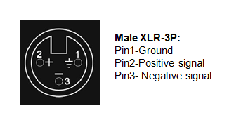
- LINE 3 input
- LINE 4 input
- EMC input
- Line output
- FM antenna

AMPLIFIER OPERATION GUIDANCE

100V Line System
For 100V line systems, connect the amplifier to the first speaker in the system using double-insulated speaker wire which has adequate current rating to handle the total output of the amplifier.
Connect the “100V” output terminal to the positive (+) connection of the speaker and “COM” output to the negative (-) connection of the speaker. Connect further speakers in parallel to the first speaker with all positive terminals and connected together and all negative terminals connected together as shown below.
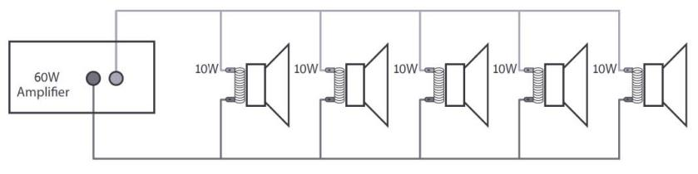
A 100V line speaker system can comprise of many speakers connected together. The determining factor for how many speakers can be used on a single amplifier is the power rating. For most purposes, it is advised to connect as many speakers as needed with a combined wattage of no more than 90% of the amplifier’s output power rating.
The terminals of a 100V speaker are connected to a transformer and in some cases, this transformer may be “tapped” for different power ratings. These tappings can be used to adjust the wattage (and output volume) of each speaker in the system to help achieve the ideal total power of the system for the amplifier.
The mixer amplifier is featured of 6 speaker zone outputs, either one of six zone or total six zone power loading shall be equivalent or no higher than the rated power of the amplifier.

Speaker Terminals
These terminals are offering 3 low voltage outputs 4Ω, 8Ω, 16Ω depending on your speaker combination. A 70V/100V commercial output is also available. Please note that one wire only should be connected to COM screw and one wire to the selected impedance or voltage. Multiple combinations cannot be done at the output level. Four different types of connections are provided. The low impedance section: 4Ω, 8Ω, 16Ω is designed for a small amount of speakers to be connected to your amplifier. The 70V/100V section is especially designed for a multiple speaker distribution. When using the 70V/100V output, speakers have to be equipped with 70V/100V transformer. The maximum amount of speakers to be placed on your distribution line is in relation to the power allocated to each speaker. The total wattage set on the secondary side of the transformers on your speaker line must not exceed the maximum RMS output power: 30W, 60W or 120W. Failure to respect this may cause permanent damage to the amplifier.

Speaker Connections
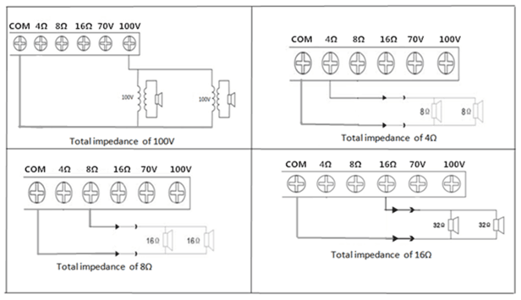

Operation Steps
- When all connections to the amplifier are made, turn all rotary controls down and switch on the power and a power “ON” LED will illuminate. Turn BASS and TREBLE controls to the 12 o’clock position (pointing straight up) and turn MASTER rotary control up part way for testing.
- Ensure a signal is being fed to one of the line inputs 1, 2, 3, 4 or 5 and gradually increase the volume control for that channel until the output is heard through the speakers. Turn up the MASTER to the maximum required volume level and reduce the channel volume control if necessary.
- Note: The initial test can be made using the built-in USB/SD/FM audio player. The output of the amplifier is represented on the level meter LEDs and care should be taken that the Red “0” LED is only lit momentarily during use. Anything longer than a short flash of this LED may be indicating distortion or clipping of the output signal and the MASTER should be turned down.
- If a microphone is connected to MIC1 input, make sure it is switched on and if it requires phantom power, make sure this feature is enabled. Gradually increase its volume control whilst speaking into the microphone until the required volume level is reached. The microphone should not be able to “hear” the speakers, which can cause feedback (squealing or howling noise).
- If the VOX feature is enabled, audio playback through channels 2-5 will be reduced in volume automatically when speaking into MIC 1, use its attenuator to increase or decrease the mute level.
- In addition to channel and MASTER volume controls, there are BASS and TREBLE EQ controls to adjust the tone of the overall output. At the 12 o’clock position, these controls are applying no effect to the signal (no boost or cut). Moving the BASS control clockwise boosts the low frequencies in the audio, whilst moving it anticlockwise will cut these low frequencies. Likewise, moving the TREBLE control clockwise boosts the high frequencies in the audio, whilst moving it anticlockwise will cut these high frequencies. Adjust these EQ controls to suit the type of audio signal or compensate for the room acoustics.

Onboard Multi-Source Audio Player

The amplifier is fitted with a built-in audio player, operated via a backlit LCD display and transport buttons. This section provides access to a Bluetooth™ receiver, FM radio tuner and USB/SD audio player
In order to play audio to one of the zones, it is necessary to press in one of the “Play” button

Mode: Select between Bluetooth, FM tuning, USB or SD playback
Play: play music
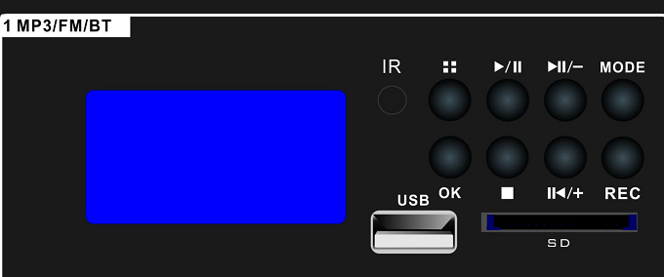
Folder: hold on the music
Prev: Back to last music
Next: go to next Music
Vol+: Increase volume
Vol-: Reduce Volume
Short press: Prev& Next
Long Press: Vol+&Vol-

Bluetooth Operation

In order to play back audio from a smartphone, tablet or other Bluetooth device, the built-in Bluetooth receiver will need to be paired with a device which is within range.”
To pair a device with the Bluetooth receiver, it is necessary to scan for devices in the Bluetooth menu of the sending device and select to pair with “BT”. Once paired, the display will show it is connect

Select to connect as an audio device and play audio tracks on the smartphone or tablet (or other) and the audio should be heard on the selected zone.

The buttons labelled “Prev” and “Next” can adjust the audio player output volume.
Press and hold “Prev” to increase volume or press and hold “Next” to decrease volume.

If the sending device goes out of range or the Mode of the audio player is changed, the connection will stop. Returning to within range or to Bluetooth mode will restore the pairing.
It may be necessary to re-select connection as an audio device on the sending device.

FM/DAB/DAB+

Press the Mode button to switch to the FM/DAB function. For good FM reception, it will be necessary to connect an external aerial to the Antenna connector on the rear panel using good quality coaxial RF cable terminated .

If no channels are tuned in, press the Play button to begin auto tuning, which scans available stations and stores them as channels within the Tuner. To step through pre-set stations, press the Previous or Next buttons.

USB/SD Player

The audio player has inputs for a USB pen drive or SD card with standard compressed digital audio files on them. Inserting either or both of these will switch the player to read from these sources and the display will show “MP3 Mode”.

After you Insert the USB it will play automatically, you can use “Prev” or “NEXT” to choose last or next song, “REPT” is for one song or all song repeat.

EMC input
If have any audio signal input from EMC input, it will cut the BGM and play EMC audio in highest proirity

CONNECTION DIAGRAMS
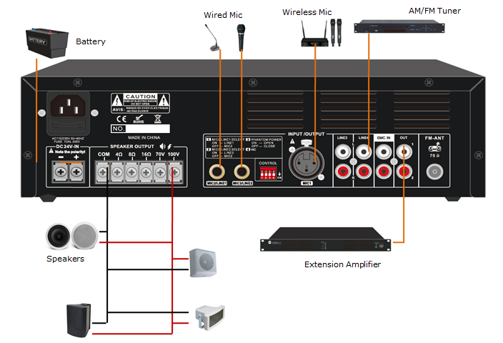

SPECIFICATION SHEET

Model | FA-30EB | FA-60EB | FA-120EB
Description | PA Amplifier with USB/SD & FM & Blue Tooth
Rated Power Output | 30W | 60W | 120W
Speaker Outputs | 100V or 70V & 4Ohms-8 Ohms-16 Ohms
Connector | Mic1 input by balanced XLR with phantom power  Input2-3 inputs Mic/Line switchable unbalanced 6.3mm phone jack  Line1-2 inputs by RCA; Line output by RCA
Attenuation | Microphone1-3, line1-2 and Mp3/FM, bass/treble and master
Input | MIC1-3: 5-8mV, 600Ω; Line, 150-470mV, 10KΩ, unbalanced RCA
Line Out | 0.775(0dBV)
Frequency Response | 60Hz-15kHz(±3dB)
S/N Ratio | Line ≥ 85dB, Mic≥ 72dB
THD | Less than 0.5%
Protection | short-circuit, clip, overload and high temp protection
Power Consumption | 60W | 100W | 200W
Power Supply | AC220V or 115V & 24V DC /50-60Hz
Dimension | 320(W)×210(D)×90(H)mm
Weight | 3.7kg | 4.3kg | 4.9kg

SERVICE
Ensure the problem is not related to operator error, or system devices that are external to this unit. Information provided in the troubleshooting portion of this manual may help with this process. Once it is certain that the problem is related to the product contact your warranty provider as described in the warranty section of this manual.

WARRANTY
Warranty terms of global three years. While the term and warranty may vary by country and may not be the same for all products. Terms and conditions of warranty for a given product may be determined first by locating the appropriate country which the product was purchased in, then by locating the product type.

Specifications may change without pre-notice.

